Potato Leaf Disease Detection Using Convolutional Neural Network
Deep Rohit¹[0009-0000-2792-9467], Mohini Darji²[0000-0002-1508-605X] and Mr. Jatin Patel^{3[0000-0003-1359-0073]}
¹ Devang Patel Institute of Advance Technology and Research, Charotar University of Science and Technology, Changa, Anand, India.
² Devang Patel Institute of Advance Technology and Research, Charotar University of Science and Technology, Changa, Anand, India.
³ SITAICS, Rashtriya Raksha University, Gandhinagar,India.
deeprohit2163@gmail.com
mahi.darji1992@gmail.com
jatin.patel@rru.ac.in
Abstract. Potato cultivation in India has faced challenges in recent years due to diseases such as early blight and late blight. These diseases have increased production costs and negatively affected potato yields. To address this issue and enhance potato production, a research paper proposes an automated and rapid disease detection system using image processing and machine learning techniques, specifically a CNN algorithm. The paper suggests that image processing is an effective approach for detecting and analyzing potato leaf diseases. The study utilizes a dataset of over 2000 images of healthy and unhealthy potato leaves, sourced from platforms like Kaggle. To detect and classify the health status of leaves, pre-trained CNN models are employed. The results indicate that the proposed system achieves an impressive accuracy of 99.01% during testing, employing a training-to-testing data split of 80% and 20% respectively. These outcomes demonstrate that the CNN algorithm outperforms existing methods in potato disease detection. The development of an automated and accurate disease detection process for potato cultivation holds great promise. By enabling early detection and intervention, farmers can take prompt measures to mitigate the impact of diseases, leading to improved crop yields and reduced production costs. Furthermore, the digitization of this system facilitates efficient monitoring and management of potato crops, enhancing overall agricultural practices.

Keywords: Potato leaves, disease classification, convolutional neural network, classification, early blight, Late blight, deep learning.
- Introduction
Since the economies of nations like India are dependent on agriculture, either directly or indirectly, agriculture is a crucial sector in these nations. It demonstrates that we must be obliged to take care of plants from when they are young until we can harvest them [1]. Nearly 70% of India's people rely on farming. Around 80% of people who live in the countryside rely on farming. Two of the biggest issues in the agriculture sector are food security and better nutrition. The potato is one of the main meals anticipated to satisfy quantitative and qualitative demands. rich in vitamins and minerals including potassium, magnesium, iron, and vitamins C and B6 [2].

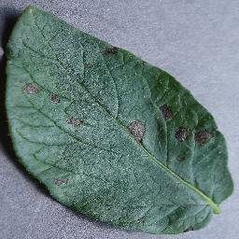 | 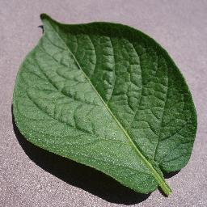 | 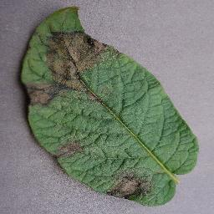
Early Blight | Healthy leaf | Late Blight
Fig. 1. Potato leave dataset
Early and late blight infections in potatoes are the most typical. The after-effects of initial decomposition are barely perceptible, with dark bruising in the majority and signs of blight observed, such as scorching with boiling water, which inevitably rots and dries out [2]. A CNN calculation is used to find the perturbations. Farmers will greatly benefit from this. Three main categories of enhanced images exist. Early, healthy, and Late blight leaves are separated into classes. A huge number of images are restricted to two categories, for example, training and testing. The remaining 20–25% of the photos are used for testing, leaving around 75–80% for training. The suggested approach divides potato leaves into healthy and sick ones. This makes it simpler for farmers to recognize such diseases and employ the appropriate fertilizer products to get rid of them, improve growth, and increase energy output. Thus, image classification has proven to be a capable technique that plays an important role in successfully validating and distinguishing evidence of plant infection status [3]. To categorize illnesses, several machine learning algorithms may be employed to compare the characteristics and patterns produced with historical data. To identify and categorize illnesses, image processing, and machine learning work very well together [3, 4].

The paper is structured in following manner: section 2 gives the study of different neural network architectures used by researchers for leaf disease detection. In addition, the paper presents a methodology that has been developed in section 3. The results and discussion of the leaf disease identification presents in the section 4. The final section of paper, section 5 summarize the finding of the study.

- Literature Survey
The agriculture industry's top concern is the early diagnosis of crop diseases. The detection and identification of plant diseases have previously been the focus of a large number of studies. Their findings on the identification of plant diseases include the following:

"Severity Identification of Potato Late Blight Disease from Crop Images Captured under Uncontrolled Environment" is the title of a research study. The show was produced by the analyst using Fluffy c-mean clustering and Neural Organize. The dataset contains images from many locations, so no special preparation is required for farmers. This was the main advantage of the demonstration. A definite stumbling block was that the photographs taken by untrained farmers were disorganized, with some fragments containing unmistakable and well-founded accumulations of vacant lots [1].

A study titled "Detecting Potato Disease Using Machine Learning". The innovation used here was image editing. In this regard, using CNN Show with 90% matching accuracy was the champion. The main disadvantage of this presentation was the significant planning needed for it [2].

In the study "Detection of Potato Disease Using Image Segmentation and Machine Learning," In this research, we provide a machine learning-based rectification method for processing images that can identify and categorize illnesses in potato leaves. We used irregular Timberland machine learning computations to classify the images and achieved 97% accuracy. A particular obstacle was the inaccurate position accuracy due to machine learning calculations [3].

Monzurul Islam developed a method to enable disease analysis in leaf photos that combines image editing and machine learning. This automated system divides potato plant crops into healthy and unhealthy ones using an open picture known as a "plant village." With an accuracy of nearly 95% for the planned exhibition, this segmentation and classification performed using the Bolster vector machine approach show the categorization of about 300 photos. As a result, the suggested strategy offers a way to completely eradicate programmed plant disease on a massive scale. A robotized, user-friendly system is created using a multi-class SVM image department. With little computational effort, it is possible to identify potato intrinsic infestations like late and early scourge. This advent provides composers with a practical, reliable, and effective strategy and time-saving format for the differential detection of disease [4].
Ramesh and Mr. R Hebbar et al. 2018 How to use it in a leaf-based image localization approach made a surprising discovery. In this article, arbitrary woods are used as a poor starting point for developing reliable locations and information sets Discriminatory dataset, labor extraction, classifier, and classification strategy are some of the processes that our study goes through. The datasets created by Unhealthy and Steady Tidy are collectively prepared under a random forest to collect fear and speech recordings. Challenging image characteristics. Use histogram-ordered gradients (hoarding). In general, machine learning can be used to create public information sets to easily detect the presence of plant diseases. This demo was created with the Irregular Woodland Classifier 160. Papaya takes pictures. This demo can be classified with an imprecise accuracy of 70%. Accuracy can be enhanced by using a large number of images and other nearby features with global features. To explain, BOVW (Bag of Visual Word) alongside Filter (Scale Invariant Include Change), SURF (Speed ​​Up Vigorous Highlights), and Thick [5].

Jitesh P. shah et al. 2016 explain the research into various image processing and machine learning techniques for using photos to identify crops damaged by different illnesses. This document does not examine numerous tactics, but just skimmed over the fundamental ideas of image processing and machine learning for identifying and categorizing plant diseases. This topic was thoroughly discussed while taking into account 19 document-based tests on different illnesses related to rice, natural goods, and several other plants. Scale, lack of bundling, preprocessing, mechanical segmentation, style, classification accuracy, etc. are examples of factors that affect the capture of picture information. This study was also used to stimulate the investigation and modification of the location and taxonomy of various diseases associated with rice [6].

Pooja V et al. 2017 For categorization and virus detection using machine learning, as well as picture processing, we presented a deployment device. First, it detects damaged areas in the image and prepares the image. Sections are created in this image, regions of interest are identified, and highlight extraction is performed. Finally, it is sent and received modernly through the SVM. Disease classification is performed by the Bolster vector machine, and this strategy yields better results than those already in use [7].

V. Suresh et al. 2020 proposed a cutting-edge machine learning and photo processing method for internet sites. In this approach, the photos will first be gathered and then provided to the ready classifier via the website. Once the picture is handled and extricated the highlights at that point the infection will be recognized. When a disease is detected, the website redirects users to a page with information on the appropriate pesticides, insecticides, and MRPs. It is one of the remarkable works acknowledged so long ago since each analyst sought to separate and categorize the ailments; however, this recommended method did neither because it recognized the infection nor suggested the proper pesticides for it [8].
Monitoring the agribusiness centrality and timely disease reporting mentioned above does not compromise the all-important yield. Infection detection and classification in many companies involves various procedures such as backing up data in image form, preprocessing images acquired using image processing methods, and image segmentation for characteristic detection of regions. is executed in Classify the images according to interest, highlight extraction, and finally the plan received. The methodology is loosely based on image processing strategies. This is because the proposed system is based on these techniques.

The crucial topic of crop disease detection in the agriculture sector is covered in the research projects that are presented. Implementing methods like image processing, machine learning, and classification algorithms, they propose a variety of methodologies for identifying and categorizing plant diseases. These techniques include using image modification and machine learning algorithms to accurately detect potato diseases, as well as clustering and neural organization for disease severity detection in potato crops collected in regulated situations. The studies highlight the need of prompt and accurate disease diagnosis while providing workable strategies for widespread disease identification, classification, and medication recommendations. Together, they make significant discoveries and innovations that help control crop diseases better and increase crop production.

- Methodology
Convolutional layers are followed by max-pooling layers in the employed CNN architecture. The design decreases the spatial dimensions of the input pictures and gradually pulls characteristics from them. The 2D feature maps are flattened into 1D vectors in the last layer, which is followed by fully linked layers with Relu activation. The Softmax activation function, which generates class probabilities for multi-class classification, is used in the output layer. This architecture is appropriate for your study on categorizing potato diseases since it uses the strength of convolutional operations and the Softmax activation to divide pictures of potato leaves into several illness groups.

In this project, there are multiple stages of research as can be seen from Fig. 1. In the form of research framework. In the proposed research framework, there are four stages which are as follows:

Early Blight | Healthy leaf | Late Blight
Fig. 2. Image data

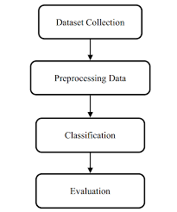
Fig. 2. Proposed Framework
  - Dataset Collection
The data set used in this hike is images of harvested potatoes, divided into three categories: Healthy leaf, early blight, and late blight. The dataset, titled "Plant Leaf Dataset," was obtained from his Kaggle page. The total amount of data used is:
Table 1. Dataset details
Classes | No of Images
Early Blight | 1000
Healthy Leaf | 152
Late Blight | 1000
Total | 2152

  - Data Pre-processing
This arrangement divides the 2152 potato leaf images into three classes. The table below contains key points regarding the distribution of information from each course to dataset preparation and review in his 80:20 ratios. The results of this shared information are prepared and checked for accuracy.
Table 2. Training and Testing data distribution

Dataset | 80:20
Dataset | Train | Test
Early Blight | 800 | 200
Healthy Leaf | 120 | 32
Late Blight | 800 | 200
Total | 1720 | 432

  - Classification
Following the aforementioned procedure, we must categorize the picture using convolutional neural network (CNN) technology. CNN may fall under machine learning. It is one of the unique types of artificial neural networks that are used for a variety of applications and data types. A CNN is often used for tasks that require the handling of pixel data and is sometimes referred to as a form of organized strategy for large learning computations. To this extent, the leaf pictures will be convoluted with a channel. At that point, surveying will be connected to decrease the measurements of the highlight maps. Therefore, the number of stored parameters and the number of calculations performed inside the device are reduced. At final, Max surveying will be utilized on the yield picture for the choice of the greatest component from the highlight outline secured by the channel.
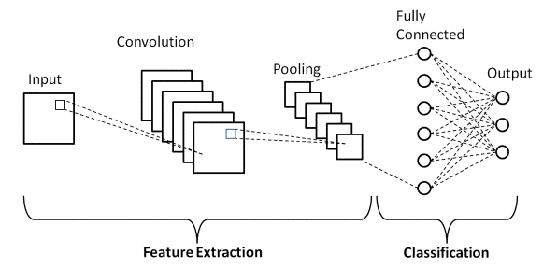

Fig. 3. CNN Architecture
  - Model Building

Using CNN, the sequential model is formed. For this, we have used rectified linear units. SoftMax is also used like an activation for forecasting.
$P\left(x\right)=\frac{{e^{x}}^{t}w^{l}}{\sum_{k=1}^{k}{{e^{x}}^{t}w^{l}}}$ (1)

Which relies on the highest probability. The prerequisites for the Softmax job are listed below:
Here, XT W infers X and W inside items.

- Results and Discussion
By regulating the biotic elements that lead to severe environmental disasters, deep learning techniques play a crucial role in plant leaf sickness detection. We present a multi-level profound learning potato leaf infection location to categorize potato leaf infections in our extended It generated them by removing the potato removes from the first layer's image of the potato removes. At the moment layer it classified the potato takes off into Early scourge and late curse illnesses utilizing convolutional neural arrange. At the same time, it takes into account the impact of natural variables on potato leaf infection.

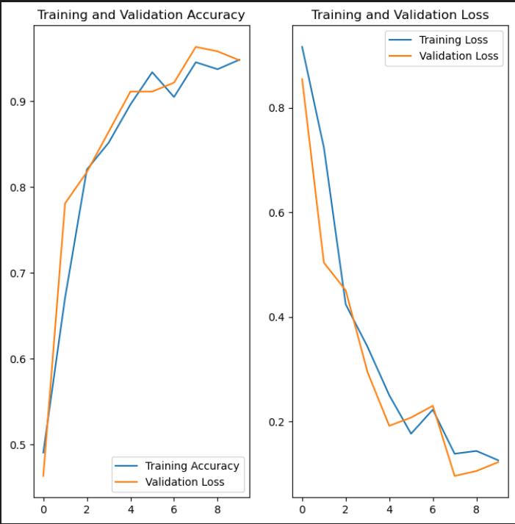
Fig. 4. Training, validation accuracy and loss
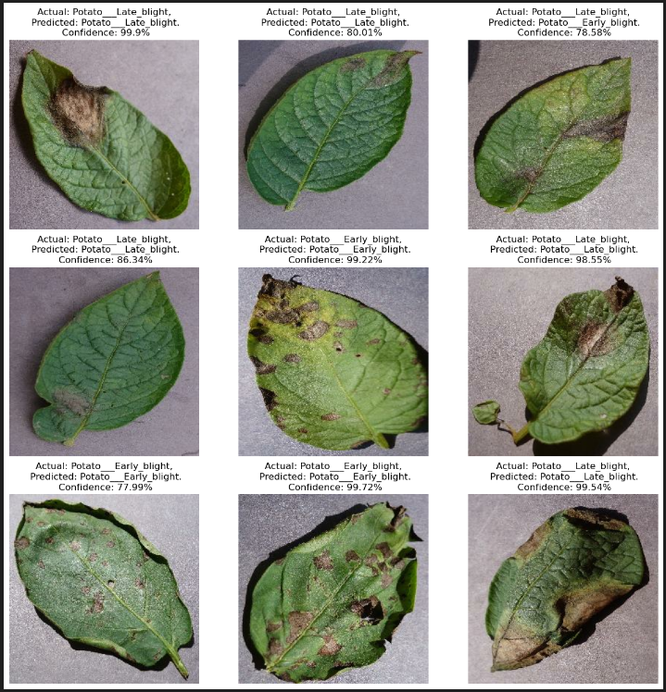
Fig. 5. Output images
- Conclusion
This project proposes a classification-based approach using deep learning techniques, specifically convolutional neural networks (CNN), to detect late blight, early blight, and healthy leaf images in potato plants. The researchers found that CNN is the most suitable method for this type of classification, achieving an impressive validation accuracy of 99.01%. This project holds great importance for the agricultural sector, particularly in India where many farmers lack literacy and knowledge about plant diseases. Implementing this work could significantly benefit potato growers by improving disease awareness and management. The experiments conducted on healthy and diseased leaf images demonstrated the effectiveness of the proposed method in accurately identifying different types of potato leaf diseases.

In the future, the application of potato leaf disease detection using CNN can lead to the development of a real-time mobile app for farmers to capture and analyze leaf images. Integrating precision agriculture techniques, such as aerial imaging, will enable targeted identification and treatment of diseased areas in large-scale potato fields. Additionally, a decision support system can provide farmers with tailored recommendations on treatment options, intervention timing, and crop rotation strategies based on disease detection outputs and environmental data. These advancements will optimize disease management, reduce pesticide usage, and enhance overall crop health in potato farming.

References
- S. Biswas, B. Jagyasi, B. P. Singh and M. Lal, "Severity identification of Potato Late Blight disease from crop images captured under uncontrolled environment," 2014 IEEE Canada International Humanitarian Technology Conference - (IHTC), Montreal, QC, Canada, 2014, pp. 1-5, doi: 10.1109/IHTC.2014.7147519.
- M. I. Tarik, S. Akter, A. A. Mamun and A. Sattar, "Potato Disease Detection Using Machine Learning," 2021 Third International Conference on Intelligent Communication Technologies and Virtual Mobile Networks (ICICV), Tirunelveli, India, 2021, pp.800-803,doi:10.1109/ICICV50876. 2021.9388606.
- M. A. Iqbal and K. H. Talukder, "Detection of Potato Disease Using Image Segmentation and Machine Learning," 2020 International Conference on Wireless Communications Signal Processing and Networking (WiSPNET), Chennai, India, 2020, pp. 43-47, doi: 10.1109/WiSPNET48689.2020.9198563.
- M. Islam, A. Dinh, K. Wahid, and P. Bhowmik, Detection of potato diseases using image segmentation and multiclass support vector machine 2017, Can. Conf. Electr. Comput. Eng., 8–11.
- S. R. Maniyath et al., Plant disease detection using machine learning 2018, Proc. 2018 Int. Conf. Des. Innov. 3Cs Comput. Commun. Control., 41–5.
- J. P. Shah, H. B. Prajapati, and V. K. Dabhi, A survey on detection and classification of rice plant diseases 2016, 2016 IEEE Int. Conf. Curr. Trends Adv. Comput.
- V. Pooja, R. Das, and V. Kanchana, Identification of plant leaf diseases using image processing techniques 2018, Proc.- 2017 IEEE Technol. Innov. ICT Agric. Rural Dev., 1, 130–3.
- Suresh V, Gopinath D, Hemavarthini M, Jayanthan K, and Mohana Krishnan, Plant disease using image processing 2020, IJERT, 9, 78-82

